Exp 40

AIM: Design NFA to accept any number of b’s where input={a,b}

INPUT:

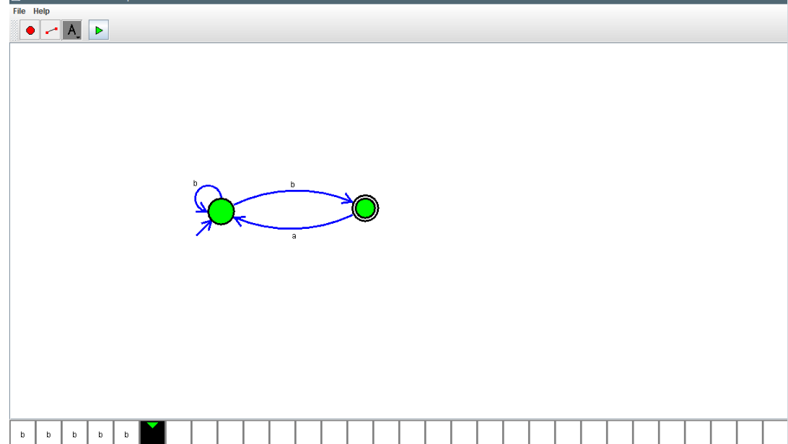

OUTPUT:



RESULT: Design NFA to accept any number of b’s where input={a,b} is verified